# Bug 1: Game does not pay out at correct level

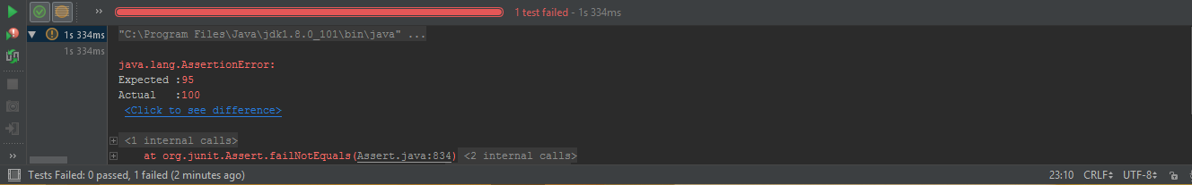

|  |  |  |  |  |
| --- | --- | --- | --- | --- |
| Attempt | Date | Time | Hypothesis | Status |
| Bug1 Attempt1 | 12/10/17 | 14:00 | The winnings are not added to the balance | Failed |
| Bug1 Attempt2 | 12/10/17 | 15:00 | The bet reduced from the balance is not added to the balance | Pass (Bug Eliminated) |

Bug:

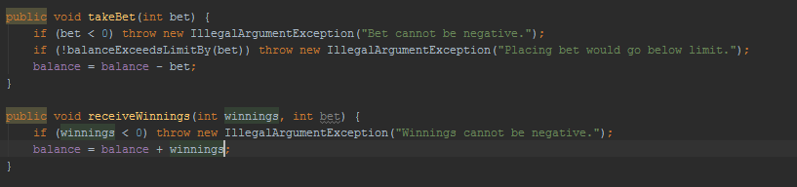

Fix:

